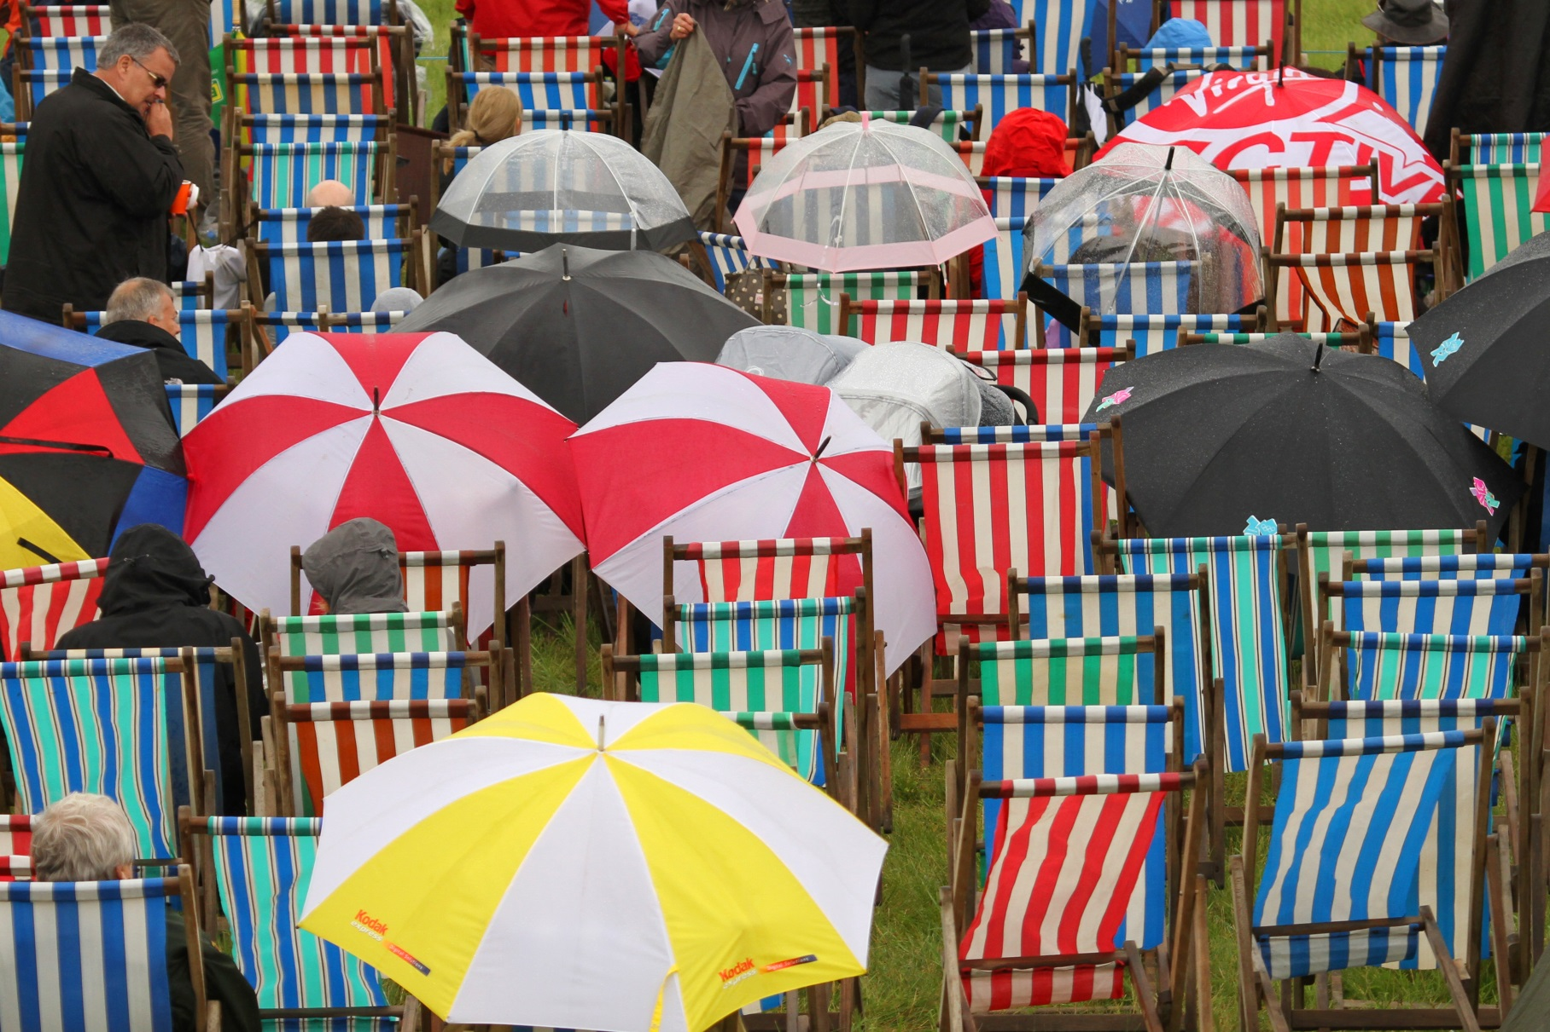

WeatherProof

Insurance Proposal Form

Tokio Marine HCC

Specialty Group

About WeatherProof

**About Us**

WeatherProof is a specific weather insurance product which has been designed to protect any business which is affected by the Weather.

Through our exclusive partnership with Weather Analytics, a leading provider of global weather data and predictive analytics, we can supply global weather insurance solutions based on the precise latitude and longitude of your risk, providing tailored, scientific cover to suit your exposure to snow, rain, wind, or extremes of temperature.

**Why Choose WeatherProof?**

50 times more global historical climate data than any other provider, hour by hour for every country and every ocean.

Fast and efficient claims service. Provision of a verification report within 48 hours. No onsite observers, no loss adjusters, no hassle.

**Who We Insure**

Wherever you are in the world, whatever your industry sector, we can source individual weather insurance solutions for your specific exposure whether this is Event, Leisure, Sport, Film and TV. Agriculture, Construction, Energy, Food and Drink, Retail, Tourism or Local Authority.

**Our Products**

Event, Film and TV, Cost Containment, Income Stabilisation or Sales Promotion

**How it Works**

We price and verify using the same data source. We recommend that you read **Addendum 2** for full details but in short, our verification sources are:

* Our **Gridded Data System Model.** Weather Analytics split the world into grids ranging from 1km by 1km in radius to 30km by 30km depending on the **Insured Weather Location** and the **Insured Weather Peril.** Your location will be situated somewhere in one of these grids. The data for each grid is sourced from Weather Stations, Radars and Satellites and your pricing and verification will be based on an average of the weather readings across your grid. Or
* A **Ground Weather Station** which records and reports on the **Insured Weather Perils** as selected by you.

The choice is yours.

As such, a WEATHER ANALYTICS LLC WDPS report will be the **ONLY** weather data report relied upon in the settlement of a claim under a purchased Policy. Please see Addendum 3.

In the event of **verified loss** under this policy, **we** will pay the **amount** stated in the **schedule** in full.

**What We Need**

A completed proposal form as below. If you would like to include more information, please append it to this submission.

Because this insurance covers weather, it is a requirement that we receive a fully completed application **at least 14 days** prior to the event date and before binding, we require that you sign **Addendum 3** in acceptance of the policy terms and conditions.

**Contact**

If you have any further questions, please don’t hesitate to contact us on:

[weatherproof@tmhcc.com](mailto:weatherproof@tmhcc.com) or +44 (0)20 7648 1282 or at [www.tmhccweatherproof.com](http://www.tmhccweatherproof.com)

Proposal Form

About the Insured

|  |  |  |
| --- | --- | --- |
| **Insured / Company Name** |  | |
| **Address:** |  | |
|  | **City / County:** | **Postcode:** |

Insured Weather Exposure

|  |  |  |
| --- | --- | --- |
| **Type of event or business** |  | |
| **Name of event or type of exposure** |  | |
| **Venue** |  | |
| **Address** |  | |
| **Post Code:** | |
| **Latitude** | **Longitude** |

Insured Weather Period

|  |  |
| --- | --- |
| **Period of cover(s)** | **Date(s):** |
| **Start / End Hour(s) (24 hour):** |

Insured Weather Peril (see attached definitions)

|  |  |  |  |  |  |  |
| --- | --- | --- | --- | --- | --- | --- |
| **Weather peril type** | **Rain: Incremental Accumulation** | | | | | |
| **Rain: Non Consecutive Dry Hours** | | | | | |
| **Rain: Consecutive Dry Hours** | | | | | |
| **Snow: Incremental Accumulation** | | | | | |
| **Temperature: Maximum** | | | **Temperature: Minimum** | | |
| **Wind: Maximum Sustained Excluding Gusts** | | | | | |
| **Wind: Gusting** | | | | | |
|  | **Other (Please Specify)** | | | | | |
| **Units** Please tick | | cm | mm | | inches | kph |
| mph | Celsius (°C) | | Fahrenheit (°F) |  |
| **Threshold(s) Required** | | See addendum 1 for a rainfall guide and the Beaufort wind scale | | | | |

Sum Insured

|  |  |
| --- | --- |
| **Currency** |  |
| **Amount (please provide a per day breakdown (if necessary)** |  |
| **Representing** Note: This does not have to represent your 100% exposure |  |

Sales Period

|  |  |  |
| --- | --- | --- |
| **If your Insured event is a sales promotion, please state the sales period(s) below (dates and times):** | **From:** | **To:** |

Declaration

Please read the below declaration and sign:

I/We agree that this proposal form and all other written information which is provided are incorporated into and form the basis of any contract of insurance.

|  |  |  |
| --- | --- | --- |
| **Signature** |  | **Date** |
|  |  |  |
| **Name** |  | **Position:** |

|  |
| --- |
| **Contact Us**  Tel +44 (0)20 7702 4700 specialty@tmhcc.com tmhcc.com  Tokio Marine HCC - Specialty Group is a trading name of HCC Specialty Ltd, which is a member of the Tokio Marine HCC Group of Companies. HCC Specialty Ltd is authorised by the Financial Conduct Authority (FCA). Registered in England and Wales No. 04434904 with registered office at 1 Aldgate, London, EC3N 1RE. |  tmhcc.com |

Insured Weather Peril Definitions

Rain: Incremental Accumulation

The total quantity of rain to fall within the Insured Weather Period at the Insured Weather Location.

Rain: Non-Consecutive Dry Hours

A specified number of insured dry hours which pass in within the Insured Weather Period at the Insured Weather Location. A dry hour is defined as an hour in which less than a pre-determined quantity of rain falls.

This predetermined quantity is usually 0.01 inches but it can be more if the Insured so wishes and so instructs.

In the example below, a client has bought the following cover:

**Insured Weather Period**:   
15/07/2015. 8am-8pm.

**Insured Weather Peril**:  
Rain: Non Consecutive Dry Hours (9 hours from 12) i.e. the client needs any 9 dry hours between 8am and 8pm for their event to go ahead or to complete their film shoot. So a claim is triggered if there are 4 hours or more between 8am and 8pm in which the requested rain threshold occurs per hour.



Rain: Consecutive Dry Hours

A specified number of insured dry hours which pass in consecutive, chronological order within the Insured Weather Period at the Insured Weather Location. A dry hour is defined as an hour in which a pre-determined quantity of rain or less falls.

This predetermined quantity is usually 0.01 inches but it can be more if the Insured so wishes and so instructs. In the example below, a client has bought the following cover:

**Insured Weather Period:**   
being 15/07/2015. 8am-8pm.

**Insured Weather Peril being Rain:**   
Consecutive Dry Hours (9 hours from 12) i.e. the client needs 9 consecutive dry hours between 8am and 8pm for their event to go ahead or to complete their film shoot.



Snow: Incremental Accumulation

The total quantity of snow to fall within the Insured Weather Period at the Insured Weather Location.

Temperature: Maximum

The maximum temperature recorded within the Insured Weather Period at the Insured Weather Location.

Temperature: Minimum

The minimum temperature recorded within the Insured Weather Period at the Insured Weather Location.

Wind: Maximum Sustained Excluding Gusts

Defined as the maximum hourly wind average recorded during the Insured Weather Period.   
E.g. if the cover was in force for 4 hours between 7am and 11am and the wind averaged 25kph, 28kph, 29kph and 15kph respectively , then the recorded Wind: Maximum Sustained Excluding Gusts would be 29kph.

Wind: Gusting

The maximum instantaneous wind gust recorded within the Insured Weather Period at the Insured Weather Location.

**Addendum 1 - Rainfall Thresholds and Beaufort Scale**

These threshold descriptions are merely a guideline to help you choose the right coverage for your exposure.

**Rainfall Thresholds**

**1/100 (.01) Inch of Rain (0.025cm)** - The least amount of measurable rainfall recorded by the national weather service. This amount would not leave puddles on the ground and would slightly wet the surface. Considered to be non-intrusive to outdoor events. Example: A light shower for 2-5 minutes or drizzle for two hours.

**1/10 (.10) Inch of Rain** **(0.25cm)-** A light rain for 30-40 minutes, moderate rain for 10 minutes or heavy rain for 5 minutes. Small puddles would form but usually disappear after a short while.

**1/4 (.25) Inch of Rain** **(0.635cm)** - A light rain for 2-3 hours, moderate rain for 30-60 minutes or heavy rain for 15 minutes. Many puddles on ground that do not disappear easily.

**1/2 (.50) Inch of Rain** **(1.27cm)** - Moderate rain for 1-2 hours or heavy rain for 30-45 minutes. Deep standing water for long periods of time (a light rain never reaches this amount).

**3/4 (.75) Inch of Rain**  **(1.91cm) -**  Heavy rain for 2-4 hours. Deep standing water for long periods of time (a light or moderate rain never reaches this amount).

**1 Inch of Rain (2.54cm)** - Heavy rain for several hours (2-5 hours). Deep standing water for long periods of time (a light or moderate rain never reaches this amount).

**Beaufort Wind Scale**



**Addendum 2 - Weather Analytics LLC Gridded Data System Model**

At point of purchase an **Insured** has two **Claims Verification** options**,** eithera specified **Ground Weather Station** **OR** the **Gridded Data System Model**. The chosen option will be expressly stated on the schedule and the **Insured** agrees to employ **Weather Analytics LLC** to record the **Insured Weather Peril** for the **Insured Event** and understands and agrees that the **Weather Analytics LLC WDPS Report** will be the ONLY weather data report relied upon in the settlement of a claim under this policy. The **Weather Analytics LLC WDPS Report** will use ONLY the specified **Ground Weather Station** **OR** the **Gridded Data System Model** as stated on the schedule and as chosen by the Insured.

**Ground Weather Station** verification

A **Ground Weather Station** is weather station with instruments and equipment for measuring atmospheric conditions at a fixed location. A **Ground Weather Station** can only be used if it:

* Meets the qualitative and quantitative data requirements of **Weather Analytics LLC**
* Records and reports upon the **Insured Weather Peril** per the **Insured Weather Period** parameters, both as selected by the **Insured.**

**Gridded Data System Model** verification

The **Gridded Data System Model** is an algorithmically based model used by **Weather Analytics LLC** to provide weather statistics and **WDPS Reports**. It uses weather statistics relevant to your **Insured Weather Location** taken from the following sources:

* Over 40,000 **Ground Weather Stations**
* Public sources (example: NOAA MADIS- *Meteorological Assimilation Data Ingest System*)
* Airports (example: METAR- *METeorological Aviation Report*)
* Weather radar (example: National Weather Service NEXRAD Radar network)
* Satellites (example: GOES- *Geostationary Operational Environmental Satellite*)
* Gridded data (example: CFSR- *Climate Forecast System Reanalysis)*

Weather Analytics then fuses, cleanses, formats, and rationalises the data and then groups it into source resolutions or data grids. These resolutions or grids are essentially geographical areas of varying km squared size (depending on the Insured Weather Peril and the territory) within which your **Insured Weather Location’s** Latitude and Longitude will be situated.

The gridded data has many advantages over Ground Weather Station methods because it has consistent coverage and is always available, where high-quality **Ground Weather Stations** are not. For example, there can be huge variability between stations which are seemingly close to each other due to terrain, siting and accuracy of sensors.

As expressly sated on **Your** **Schedule**, the gridded data is calculated to the following **km** resolutions:

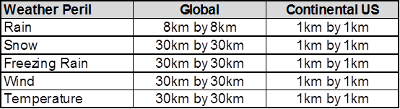

Upon notification of a claim under this policy, **we** will request a **WDPS Report** from **Weather Analytics LLC** and we will confirm to you as soon as is reasonably possible whether or not **Your** claim has been verified, confirming either:

* Claim Triggered, meaning that **Your** claim has been verified
* Weather Avoided, meaning that **Your** claim has been denied

If **You** are still not satisfied and there are potential grounds for an additional review, e.g. The precipitation or temperature during the insured time period was very close to triggering a claim but did not, the **WDPS Report** will be reviewed by the senior meteorology team. All reviewers will then use any data sources available to compile a report representative of the insured location including any nearby **Ground Stations** which meet **Weather Analytics LLC’s** required **Insured Weather Peril** and data standards.

It is at the sole discretion of the senior meteorologists to approve the report or change the report.

Weather Analytics LLC

3 Bethesda Metro, Suite 508, Bethesda, Maryland 20814

Unless stated otherwise in the schedule, the **Insured** agrees to employ **Weather Analytics LLC** to record the **Insured Weather Peril** for the **Insured Event** and understands and agrees that the **Weather Analytics LLC** **WDPS Report** will be the ONLY weather data report relied upon in the settlement of a claim under this policy.

The same **Weather Data Production System (“WDPS”)** is used for both policy rating and also claims verification.

**WEATHER ANALYTICS LLC maintains, in the ordinary course of business, a Weather Data Production System (“WDPS”) for a variety of government and commercial users. It** provides unbiased location-specific measurements by implementing the latest methods and tools in weather technology reporting. These include modeling algorithms and software developed exclusively by **WEATHER ANALYTICS LLC**; weather products from the National Weather Service; and worldwide data services. The **WEATHER ANALYTICS LLC** staff of meteorologists has immediate access to weather observations that are taken at least hourly, and often more frequently, throughout the world.

**WEATHER ANALYTICS LLC** systems provide forensic remote measurements by assimilating, analyzing and interpolating data to determine storm track and intensity for precipitation in various forms. It uses satellite imagery and live weather radar (if available in your area) encompassing your specific event location (Latitude / Longitude). **WEATHER ANALYTICS LLC** can report rainfall, snowfall, temperatures, and other measurable weather occurrences.

Dr. John L. Keller, formerly with MIT Lincoln Laboratory, founded **WEATHER ANALYTICS LLC.** His clients have included the U.S. Defense Department and the U.S. Intelligence Community. Dr. Keller holds the American Meteorological Society’s Certified Consulting Meteorologists (CCM) designation. His professional career in atmospheric sciences spans nearly 40 years. **WEATHER ANALYTICS LLC’s** staff of meteorologists can be personally called upon to discuss your specific situation or concerns.

Tokio Marine HCC has a minority ownership interest in Weather Analytics LLC. Tokio Marine HCC – Specialty Group has contracted with Weather Analytics exclusively to provide hyper-local climate data in the sports, hospitality, entertainment and leisure space in order to more accurately verify weather conditions at the exact location of the event.

**By signature below, I agree to employ WEATHER ANALYTICS LLC to record the Insured Weather Peril for my Insured Event using the methodology selected. I fully understand and agree that the WEATHER ANALYTICS LLC WDPS report will be the ONLY weather data report relied upon in the settlement of a claim under my insurance policy.**

|  |  |
| --- | --- |
| **Ground Weather Station**  **OR** |  |
| **Gridded Data System Model** |  |
| **Furthermore, by ticking this box, I agree that**  **The Policy Language for this Insurance shall**  **be ENGLISH** |  |

|  |  |
| --- | --- |
| **Name:** | |
| On behalf of (Insured): | |
| Signature: | Date: |

**NOTE: This form must be fully completed, signed and returned to Tokio Marine HCC Specialty in order to use WEATHER ANALYTICS LLC for the relevant weather recordings under your insurance policy.**

**Tokio Marine HCC – Specialty Group** Fitzwilliam House**,** 10 St. Mary Axe**,** London**,** EC3A 8BF

**Data Protection Clause**

Tokio Marine HCC respects your right to privacy. In our Privacy Notice (available at https://www.tmhcc.com/en/legal/privacy-policy) we explain who we are, how we collect, share and use personal information about you, and how you can exercise your privacy rights. If you have any questions or concerns about our use of your personal information, then please contact DPO@tmhcc.com.

We may collect your personal information such as name, email address, postal address, telephone number, gender and date of birth. We may also collect your sensitive personal information such as data relating to your physical or mental health or condition. We need the personal or sensitive personal information to enter into and perform a contract with you. We retain personal information and sensitive personal information we collect from you where we have an ongoing legitimate business need to do so.

We may disclose your personal or sensitive personal information to our **group companies, third party services providers and partners** who provide data processing services to us, or who otherwise process personal or sensitive personal information for purposes that are described in this Privacy Notice or notified to you when we collect your personal or sensitive personal information; to any **competent law enforcement body, regulatory, government agency, court or other third party** where we believe disclosure is necessary (i) as a matter of applicable law or regulation, (ii) to exercise, establish or defend our legal rights, or (iii) to protect your vital interests or those of any other person; to a **potential buyer** (and its agents and advisers) in connection with any proposed purchase, merger or acquisition of any part of our business, provided that we inform the buyer it must use your personal and sensitive personal information only for the purposes disclosed in this Privacy Notice; and to any **other person with your consent** to the disclosure.

Your personal and sensitive personal information may be transferred to, and processed in, countries other than the country in which you are resident. These countries may have data protection laws that are different to the laws of your country. We transfer data within the Tokio Marine group of companies by virtue of our Intra Group Data Transfer Agreement, which includes the EU Standard Contractual Clauses.

We use appropriate technical and organisational measures to protect the personal information that we collect and process about you. The measures we use are designed to provide a level of security appropriate to the risk of processing your personal information.

You have the following data protection rights: **access, correct, update or request deletion, object to processing, restrict processing and in some cases request portability.**

You can **opt-out of marketing communications** we send you at any time. You can exercise this right by clicking on the “unsubscribe” or “opt-out” link in the marketing e-mails we send you. Similarly, if we have collected and processed your personal or sensitive personal information with your consent, then you can **withdraw your consent** at any time. Withdrawing your consent will not affect the lawfulness of any processing we conducted prior to your withdrawal, nor will it affect processing of your personal information conducted in reliance on lawful processing grounds other than consent. You have the **right to complain to a data protection authority** about our collection and use of your personal information.